Sign with Smart connectivity For Road Better

**safety**

To 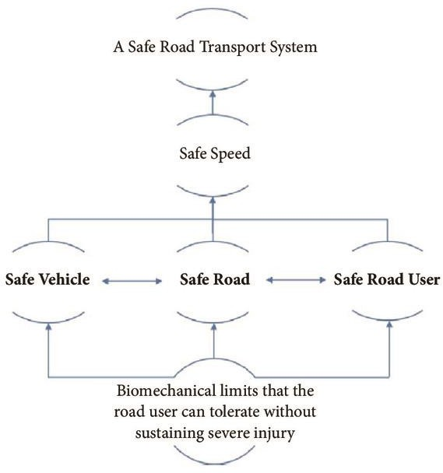 Safe-

System- based Safe Road Transport Systems, with its elements: safe vehicle, safe road, and safe road user

# safe vehicle

Emphasis on vehicle safety is verifed through mandated regulatory testing and rating, as well as technologies such as electronic stability control. Beyond this, enforced checks (e.g., upon license renewals) combined with on the road reporting work to review the status of vehicle safety

# safe Road

Te assessment of road (or road network) safety is multifaceted. Road inspection enables clear and direct observation of the state of the road and assesses the need for repairs or modifcations. Te structure of the road network is amenable to safety assessment through partitioning into what is called “Trafc Analysis Zones (TAZs)” [8]. In addition, considerations for crash data and other supporting data ofer further insights into general safety assessment. In 2011, the European Road Assessment Programme (EuroRAP) generated the European Road Safety Atlas for EU countries [9]. Te atlas indicated the safety level of roads with a star rating based on specially equipped vehicles for multimedia-based data aggregation [10]. Te EuroRAP eforts continue to implement an SS approach across the EU, along with several other national programmes within international RAP, or iRAP, initiative [11].

# 3 .safe Road user

Tere are several aspects to road user safety, including measures for education and awareness, travel distance, exposure, licensure, enforcement, and sober Wireless Communications and Mobile Computing

driving [5]. Te need for such characterization rises substantially as the fndings of crash report analysis in cities typically note a critical dependence on either driver behavior or driver awareness [12]. A great need is further established in these studies for innovative mechanisms to instill safe driving at the licensing and post- licensing stages.

1.2. Contributions. Figure 2 illustrates elements of assessing road safety. It can be seen in the fgure that the scope of consideration in the SS approach is medium-to-long term, facilitating by design, systemic actions that are made to ensure the safety of the road network. While the use of “data monitoring systems” is motivated in [4] and can be utilized for shorter term scopes, the general emphasis is maintained at the medium-to-long term reaction cycles. Our interest in this work is to extend SS to the short-tomedium term through exploiting recent advances in the context of the Internet of Tings (IoT) and Intelligent Transport Systems (ITS) [13, 14]. Tis fts the outlook for Smart Cities where automation is emphasized to address the increasing dynamic nature of city

elements [15]. Toward this, our contributions in this work are as follows: (i) Tis work ofers a comprehensive, IoT-based architecture with the objective of assessing the safety of the transportation road network. (ii) In doing so, the proposed architecture is aligned with the SS approach in its entirety. (iii) It also complements the SS approach by addressing the void in its short-to-medium scope of considerations, making the approach further ftting to the dynamic nature of smart cities (note the scopes illustrated in Figure 2). (iv) Finally, the proposed architecture showcases the viability of an economic road safety monitoring through advances in IoT and ITS, especially those aimed at realizing smart cities. Te proposed architecture involves a novel use of machine learning as part of its road safety assessment core. Tis application facilitates assessments that are both dynamic and robust. We also showcase an application of the developed core aimed at safety-based route planning in smart cities. 1.3. Paper Organization. Te remainder of this work is organized as follows. Section 2 reviews related work and motivates and positions the contributions made herein. Section 3 introduces the dynamic road safety assessment, with descriptions on architectural considerations, while Section 4 elaborates on the dynamic assessment core.

Section 5 details an application of the developed assessment core in the context of route planning. Section 6 validates the dynamic assessment core together with a demonstration for route planning. Finally

# safety Based Routes Planning

Route planning has become widely used in both personal and commercial use, resulting in an increasing dependence on its reliability. Various applications employ efcient algorithms for route planning [43]. Trip time and cost, e.g., for tolls, have been the typical metrics for route planning applications, but other metrics, however, have been utilized, e.g., for fuel emission/consumption or energy requirements of electric vehicles. Using the dynamic safety assessment proposed above, it is now possible to route vehicles across cities based on a safety. In this manner, drivers can be directed through routes that minimizes their overall risk in traversing the road network. Meanwhile, enforcement can distribute vehicles across diferent paths to distribute risk of the network and avoid having critically unsafe links or routes within the network. It is furthermore possible to target auxiliary mechanisms for safety-control across the network by

controlling and redirecting trafc based on user driving behavior or inresponse to incidental changes in the road network.